**‘AccessBank DBA Internship Program’**

**Project 16: Activity Monitor and Task Manager**

In the middle of the day, you received a phone call from the IT director. He said that employees face with a slowness and asks you to check whether the problem is related to database or not. Use Activity Monitor and Task Manager to find out what is the bottleneck?

To simulate this scenario,

1. Open Activity Monitor and change refresh time to 1 second

**I opened it and changed refresh time by clicking right in that field:**

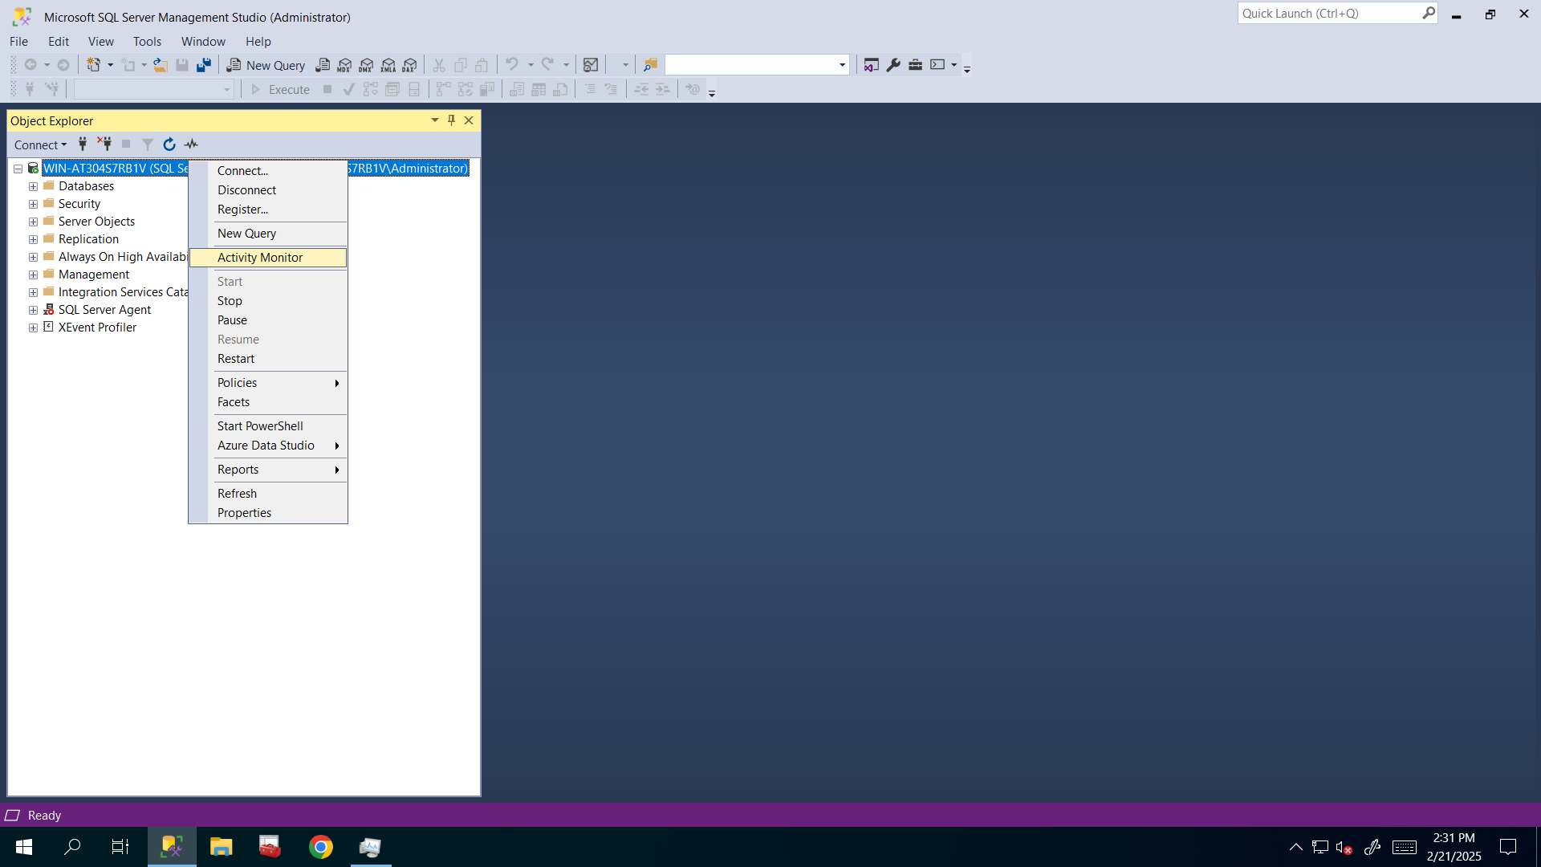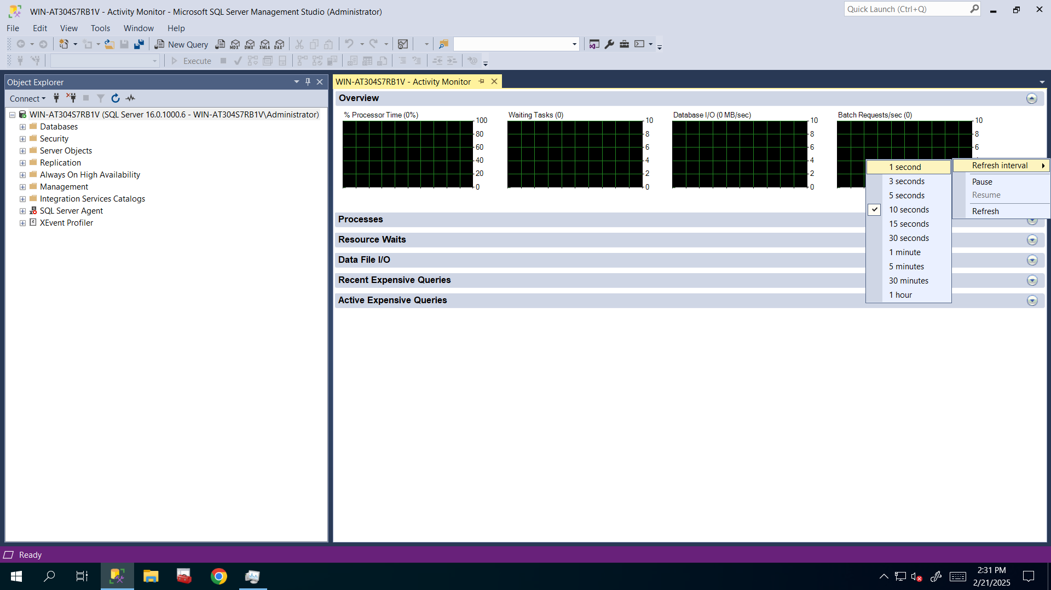

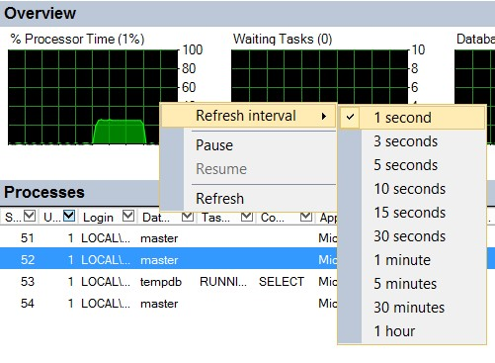

1. Open Task Manager

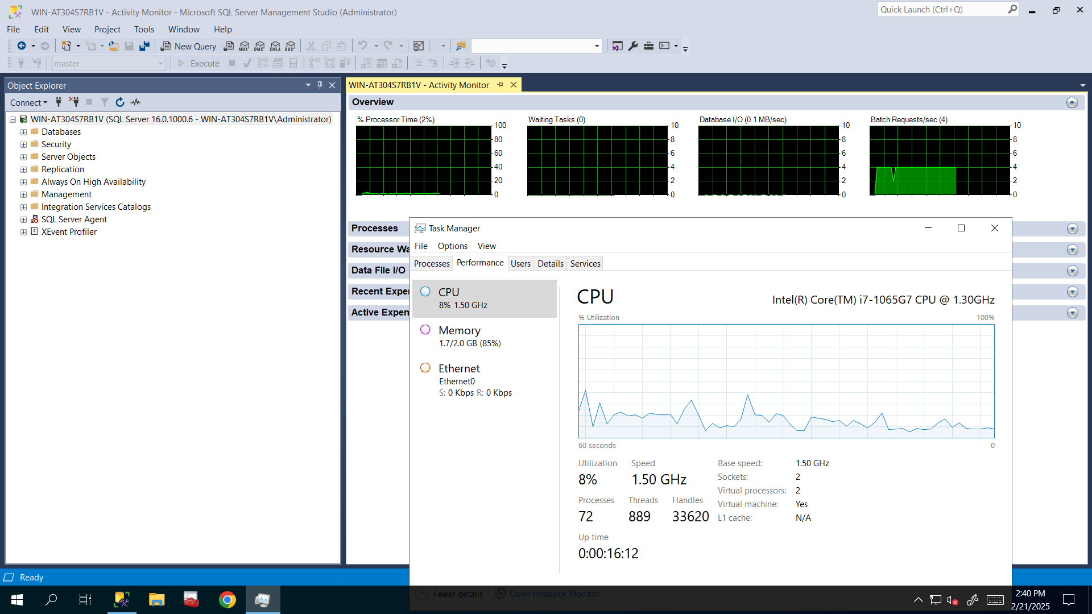

1. run the following query in the 3 different sessions at the same time:

**I run following query and observed changes in both Task Manager and Activity Monitor at the same time:**

DECLARE @SQL_Alphabet varchar(26)

SET @SQL_Alphabet = 'ABCDEFGHIJKLMNOPQRSTUVWXYZ'

DECLARE @rnd_seed int

SET @rnd_seed = 26

DECLARE @DT datetime

SET @DT = '05/21/1969'

DECLARE @counter int

SET @counter = 1

DECLARE @tempVal NCHAR(40)

WHILE @counter < 10000000000

BEGIN

SET @tempVal = SUBSTRING(@SQl_alphabet,

Cast(RAND() * @rnd_seed as int) + 1,

CAST(RAND() * @rnd_seed as int) + 1)

SET @counter = @counter + 1

END

1. Observe both Task Manager and Activity Monitor of SQL Server and identify what is the bottleneck? Is it CPU, Memory, or IO?

**I think it is CPU because CPU utilization was 8% before running the query but now in that query execution process, it sometimes uses 100% of CPU so we need to do something for that to fix that issue and to make execution process faster:**

**AS a DBA, if I can fix it, I must fix it If I can not I must say it to developer or vendor that issue and I used ChatGPT for that problem and it said that “Your SQL Server query is running an infinite loop (or at least a massive loop) with RAND() calculations inside it, which causes extremely high CPU usage.” So I have to avoid that infinite loop to minimize CPU usage.**

